Question1:

Retrive the total no order placed: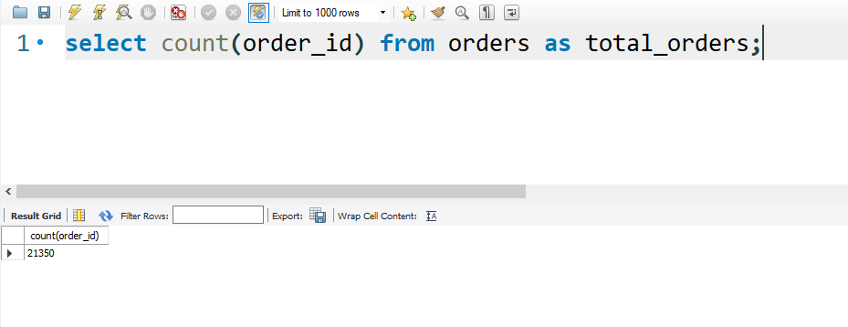

**Insight**: This metric indicates the overall demand and popularity of the pizza place.

**Recommendation**: Utilize this information to manage inventory, staff, and marketing efforts to align with demand trends. For instance, if demand is consistently high, consider expanding operational hours or increasing staff during peak times.

**How the Business Can Use This Insight to Make Improvements?**

1. **Staff Scheduling**:
   * **Improvement**: Schedule staff more effectively by understanding peak demand times.
   * **Action**: Analyze order data to identify peak hours and days, then adjust staff schedules to ensure adequate coverage during those times.
2. **Operational Hours**:
   * **Improvement**: Expand operational hours if demand is consistently high to accommodate more customers and increase sales.
   * **Action**: Evaluate demand data to determine if extending hours during peak times or opening earlier/later would be beneficial.

Question2:

Calculate the total revenue genarate:

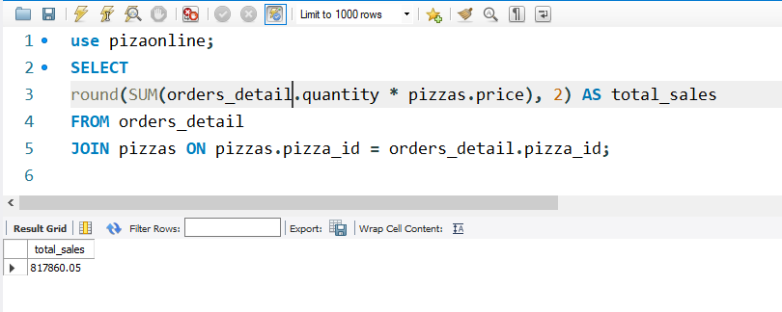

**Insight**: Total revenue reflects the financial health and success of the pizza business.

**Recommendation**: Use revenue data to identify peak periods and plan promotional activities to further boost sales during these times.

**Business Can Use This Insight to Make Improvements?**

1. **Promotional Activities**:
   * **Improvement**: Increase sales by planning targeted promotions.
   * **Action**: Develop special offers and discounts during identified peak periods to attract more customers and boost overall revenue.

Question 3:

Identify the first five pizzas highest prices:

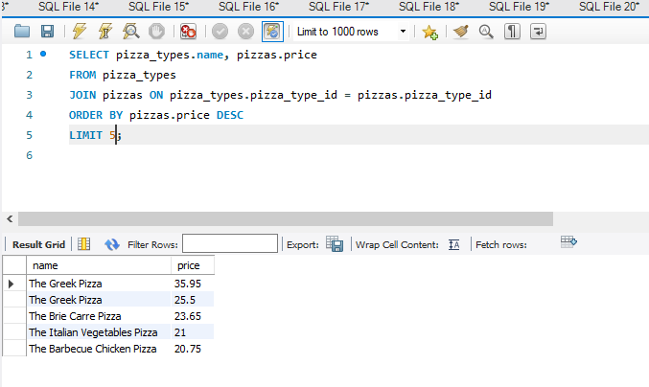

**Insight**: High-priced pizzas often contribute significantly to revenue.

**Recommendation**: Promote these premium pizzas to increase sales and profitability.

**Business Can Use This Insight to Make Improvements?**

1. **Special Offers**:
   * **Improvement**: Encourage more customers to try and purchase these premium pizzas.
   * **Action**: Offer special deals, such as discounts or bundled meal deals, that include these high-priced pizzas to increase their sales.

Question 4:

Identify the most common pizza size orders.

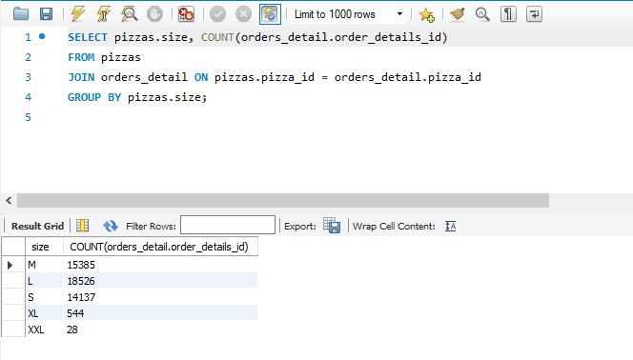

* **Insight**: Common pizza sizes indicate customer preference.
* **Recommendation**: Ensure sufficient stock and offer deals on popular sizes to meet demand.
* **Business Can Use This Insight to Make Improvements?**
* **Improvement:** Focus marketing efforts on promoting our most popular pizza sizes.
* **Action:** Create ads that highlight the variety and value of these popular sizes. Share these ads on social media and in email newsletters, along with special offers and promotions tailored to these sizes. This will help attract more customers by showing them the best options and deals available

Question 5:

1. 10 most orders pizzas type:
2. along their quantities:

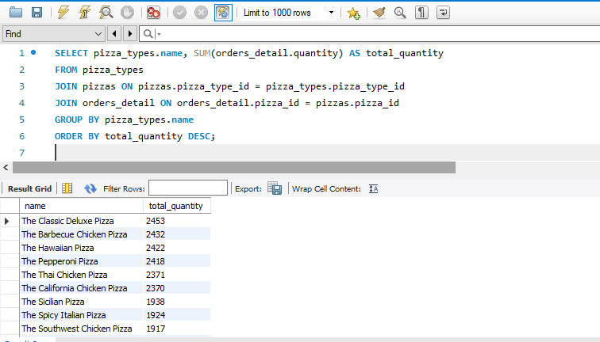

**Insight**: The most ordered pizza types indicate customer favorites.

**Recommendation**: Focus marketing and inventory efforts on these top sellers to maximize sales. Consider introducing limited-time variations of these popular types to keep the menu exciting.

**Business Can Use This Insight to Make Improvements?**

**Strategic marketing:**

**Improvement:** Concentrate marketing on the pizzas people order the most.

**Action:** Create ads that highlight these popular pizzas, showing why they're so great. Share these ads on social media, in emails, and in-store to let customers know why these pizzas are the best.

Question 6:

Total quantity of each pizza by category orders:

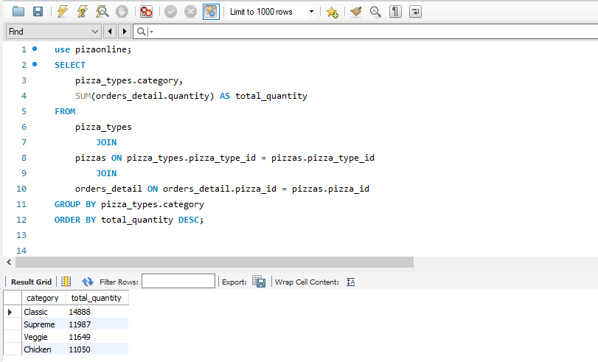

**Insight**: classis pizzas are the most popular, followed by veggie and then vegan. And chiken

**Recommendation**: Adjust your menu and stock based on these preferences. If vegan pizzas are less popular, consider promoting them more or introducing new flavors.

**Business Can Use This Insight to Make Improvements?**

**Promotional Strategies:**

* Targeted Marketing: Focus marketing efforts on promoting classic and veggie pizzas through targeted advertising campaigns and special promotions.

Question 7:

Distribution the order by hour OF the DAY

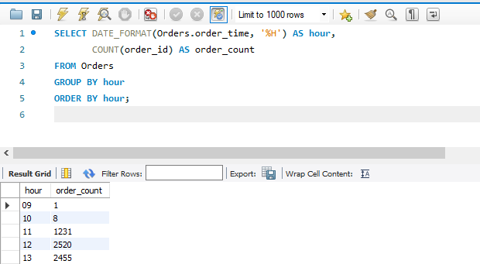

**insight**: This is the busiest time for orders.

**Recommendation**: Hire more staff during these peak hours and offer discounts during quieter times to balance the workload and keep customers happy.

**Business Can Use This Insight to Make Improvements?**

* **Reduced Wait Times:**
* With sufficient staff during busy periods, customers will experience shorter wait times for their orders, leading to a more positive dining experience.
* **Promotional Strategies:**
* Offering discounts during quieter times can incentivize customers to order, thus boosting sales during off-peak hours and maximizing revenue potential.

Question 8:

Catogery wise distribution of ordered pizzas:

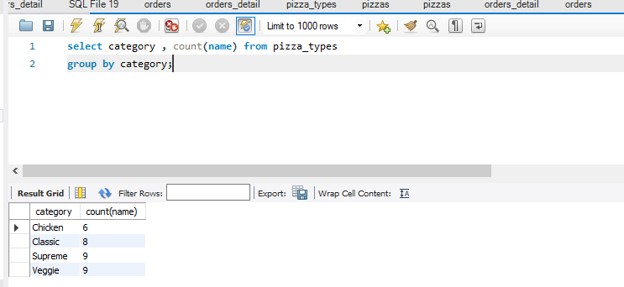

**Insight**: Non-veg pizzas are ordered the most, followed by veggie and then vegan.

**Recommendation**: Add new options or improve less popular categories to attract more customers. Highlight vegan options to appeal to health-conscious customers.

**Business Can Use This Insight to Make Improvements?**

**Menu Enhancement:**

* Introduce New Options: Develop innovative non-veg pizza varieties to expand the selection and cater to diverse tastes, thereby attracting more customers.

**Special Offers:**

Create special deals or combo meals featuring veggie and supreme options to incentivize customers to try these categories and boost their popularity.

Question 9:

Group the orders by date and calculate the average no of pizzas order per day:

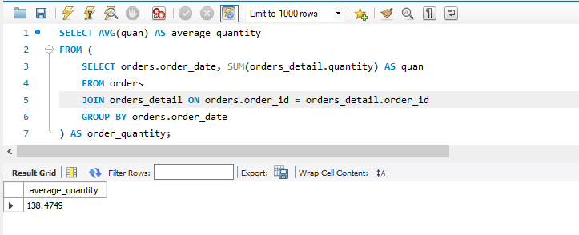

**Insight:** This shows the average daily demand for pizzas.

**Recommendation:** Use this information to plan how much stock and staff you need each day. Watch for daily trends and adjust your plans as needed.

**Business Can Use This Insight to Make Improvements?**

1. **Better Staffing:**
   * **Right People, Right Time**: Adjust staff schedules based on daily demand, so we're not short-staffed or overstaffed.
   * **Flexible Hours:** Change shifts as needed to match busy times, making sure we serve customers well without overloading our team.

Question 10:

Determine the top 3 order pizzas on revenue:

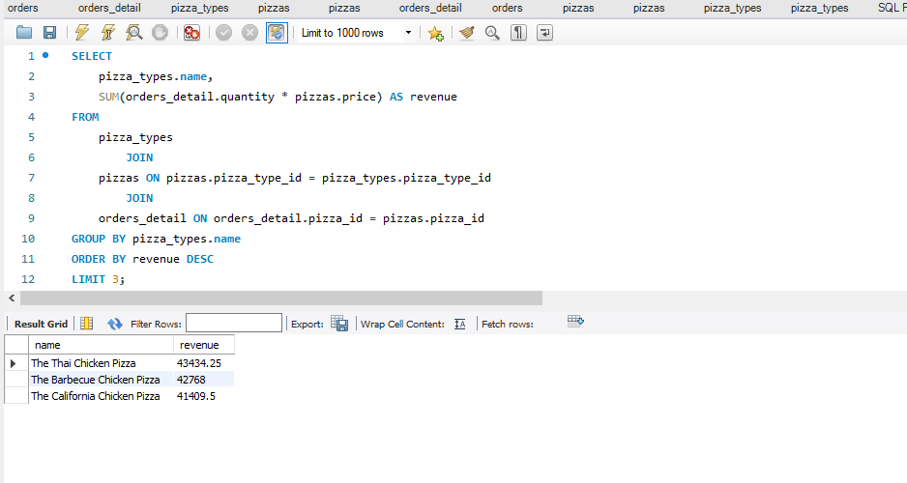

**Insight**: These pizzas bring in the most money.

**Recommendation**: Promote these pizzas more to increase their sales. Create special deals that include these top-selling pizzas.

**Business Can Use This Insight to Make Improvements?**

1. **Enhanced Marketing Focus:**
   * **Highlight Top Sellers:**
   * Feature these high-performing pizzas prominently in marketing materials, menus, and advertisements to increase visibility and customer interest.
   * **Tailored Campaigns:**
   * Develop targeted marketing campaigns specifically promoting these pizzas to attract more attention and drive sales.

Question11:

Calculate the total percentage revenue of pizza type to total revenue:

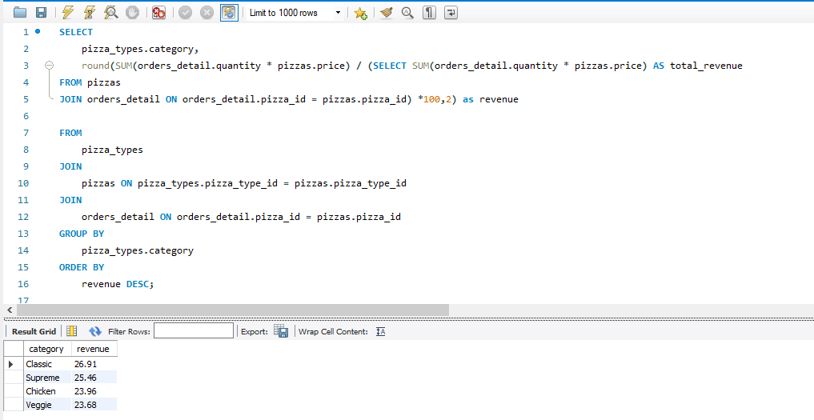

**Insight:** These types make up a large part of the total revenue.

**Recommendation:** Focus on pricing, promotions, and menu placement for these high-revenue pizzas to increase profits. Offer loyalty programs or discounts for frequent buyers of these types.

**Business Can Use This Insight to Make Improvements?**

**Menu Increase:**

* Introduce New Options: Develop innovative non-veg pizza varieties to expand the selection and cater to diverse tastes, thereby attracting more customers.

**Special Offers take over:**

Create special deals or combo meals featuring veggie and supreme options to incentivize customers to try these categories and boost their popularity.

Question 12:

Cumulative revenue over order date:

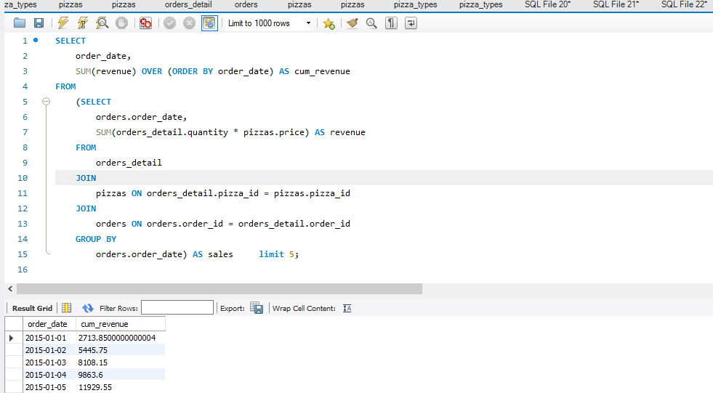

**Insight:** This shows the average daily cumulative revenue over order date of pizzas.

**Recommendation:** Use this information to plan how much stock and staff you need each day. Watch for daily trends and adjust your plans as needed for cumulative order revenue.

**Business Can Use This Insight to Make Improvements?**

**Promotional Strategies:**

* Targeted Marketing: Focus marketing efforts on promoting pizzas through targeted advertising campaigns and special promotions.
* Develop targeted marketing campaigns specifically promoting these pizzas to attract more attention and drive sales. To generate cumulative revenue order by date by this stragities